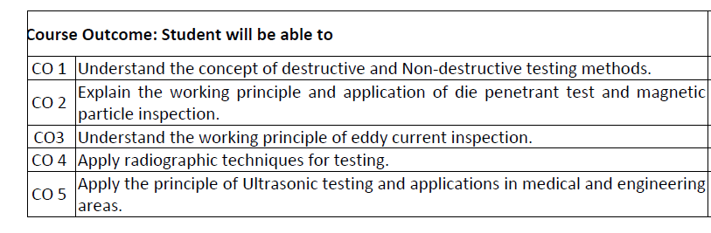

UNIT-1

Introduction

Syllabus: -

Introduction to NDT, DT, advantages & limitations of NDT, classification of NDT methods, Comparison with DT, Terminology, Flaws and Defects .Scope of NDT .Codes, Standards and Certifications in NDT.

Visual Inspection– Equipment used for visual inspection, Bore scopes, Application of visual inspection tests in detecting surface defects and their interpretation, advantages & limitations of visual inspection, Visual Inspection in welding

**Introduction to NDT: -** NDT stands for Non-Destructive Testing, which is a set of techniques used in various industries to evaluate the properties of a material, component, or system without causing damage or altering its integrity. This is crucial for ensuring the safety, reliability, and quality of products and structures. NDT methods are employed across a wide range of sectors including aerospace, automotive, construction, manufacturing, oil and gas, power generation, and more. The primary goal of NDT is to detect flaws, defects, or irregularities that could compromise the functionality or safety of a component or structure. These flaws can include cracks, voids, discontinuities, inclusions, corrosion, and other imperfections that may occur during manufacturing, fabrication, or service.NDT techniques utilize principles from various scientific disciplines such as physics, acoustics, electromagnetism, and optics. Some common NDT methods include:

Visual Inspection: The simplest form of NDT involves visual examination of the surface or structure for any visible defects or irregularities.

Ultrasonic Testing (UT): UT involves sending high-frequency sound waves through a material and analyzing the reflections to detect internal flaws or measure thickness.

Radiographic Testing (RT): RT uses X-rays or gamma rays to penetrate materials and produce images that reveal internal defects or structural features.

Magnetic Particle Testing (MT): MT is used to detect surface and near-surface flaws in ferromagnetic materials by applying a magnetic field and observing the pattern of iron particles applied to the surface.

Liquid Penetrate Testing (PT): PT involves applying a liquid dye or fluorescent penetrate to the surface of a material. After a waiting period, excess penetrate is removed, and a developer is applied to draw out any penetrate trapped in surface defects.

Eddy Current Testing (ECT): ECT uses electromagnetic induction to detect surface and subsurface flaws, measure conductivity, and characterize material properties.

Acoustic Emission Testing (AE): AE monitors the release of transient stress waves (acoustic emissions) from within a material under stress, which can indicate the presence of defects or structural changes.

Each NDT method has its advantages, limitations, and applications, and the choice of technique depends on factors such as the material being tested, the type of defect expected, accessibility, and the required sensitivity.

Overall, NDT plays a critical role in quality assurance, maintenance, and safety across numerous industries, helping to prevent costly failures, ensure regulatory compliance, and maintain public confidence in the integrity of structures and products.

**OBJECTIVE OF NDT**

• Material sorting

• Material characterization

• Property monitoring (for process control)

• Thickness measurement

• Defect Detection/ Location and

• Defect characterization. However the major task of NTD is to detect and identify the range of defects. Defects can include production flaws such as heat treatment cracks, grinding cracks, voids (pores), and fatigue cracks (Generated during service)

**Advantages & Limitation of NDT:** Non-Destructive Testing (NDT) offers several advantages and limitations, which are crucial to consider when selecting an appropriate testing method for a particular application. Here are some of the key advantages and limitations of NDT:

**Advantages of NDT:**

Safety: NDT methods allow for the evaluation of materials, components, and structures without causing damage, ensuring the safety of personnel and avoiding costly accidents or failures.

Cost-Effectiveness: By detecting flaws and defects early in the manufacturing or maintenance process, NDT helps prevent costly rework, downtime, and product failures, ultimately saving time and money.

Quality Assurance: NDT techniques provide reliable and repeatable results, enabling manufacturers to ensure the quality and integrity of their products and comply with industry standards and regulations.

Non-Destructive Nature: Unlike destructive testing methods, NDT does not require destroying or altering the tested specimen, allowing for continued use or further analysis after testing.

Versatility: NDT methods can be applied to a wide range of materials, shapes, sizes, and environments, making them suitable for various industries such as aerospace, automotive, construction, manufacturing, and more.

Early Detection of Defects: NDT can detect flaws, defects, and irregularities at an early stage, enabling timely corrective actions to be taken before they escalate into critical issues.

Real-Time Monitoring: Some NDT techniques, such as ultrasonic testing and eddy current testing, can provide real-time monitoring of materials and structures, allowing for immediate assessment and decision-making.

Environmental Friendliness: NDT methods typically do not produce hazardous waste or emissions, contributing to environmental sustainability and compliance with environmental regulations.

**Limitations of NDT:**

Detection Limits: NDT methods may have limitations in detecting certain types of defects, particularly those located deep within a material or those obscured by geometric complexities or surface treatments.

Skill Dependence: The effectiveness of NDT often depends on the skill and experience of the operator. Improper technique or interpretation may lead to inaccurate results or missed defects.

Equipment and Training Costs: NDT equipment can be expensive to purchase, calibrate, and maintain. Additionally, specialized training and certification are often required for personnel to perform NDT accurately and reliably.

Surface Preparation Requirements: Many NDT methods require proper surface preparation, such as cleaning and removing coatings or contaminants, to ensure accurate and reliable results.

Limited Accessibility: Some NDT techniques may be challenging or impossible to apply to certain materials, locations, or configurations, particularly in confined spaces or areas with restricted access.

Resolution and Sensitivity: The resolution and sensitivity of NDT methods may vary depending on the technique used, potentially limiting their ability to detect small or subtle defects.

Interpretation Challenges: NDT results may require interpretation by trained experts, and false positives or negatives can occur, leading to misinterpretation and potential errors in decision-making.

Despite these limitations, Non-Destructive Testing remains an indispensable tool for ensuring the safety, reliability, and quality of materials, components, and structures across numerous industries. Effective utilization of NDT requires careful consideration of its advantages and limitations, along with proper training, equipment selection, and implementation.

**Destructive testing (DT)**

Destructive testing is undertaken in order to understand a specimen’s performance or material behaviour, these procedures are carried out to the test specimen’s failure. Destructive testing procedures can either follow specific standards or can be tailored to reproduce set service conditions.

Destructive testing methods are commonly used for materials characterisation, fabrication validation, failure investigation, and can form a key part of engineering critical assessments, which also involves non-destructive testing (NDT) techniques such as [digital radiography](https://www.twi-global.com/technical-knowledge/faqs/digital-radiography).

## Types of Destructive Testing

Destructive Testing (DT) involves methods where specimens are intentionally damaged or altered to assess their mechanical properties, performance characteristics, or failure mechanisms. Unlike Non-Destructive Testing (NDT), DT typically renders the tested specimen unusable for its intended purpose. Here are some common types of Destructive Testing:

**Tensile Testing:** This test determines the mechanical properties of materials under tension. A specimen is subjected to an increasing tensile load until it fractures. Tensile strength, yield strength, elongation, and modulus of elasticity are some parameters measured.

**Compression Testing**: Similar to tensile testing, compression testing assesses the mechanical properties of materials under compressive loads. A specimen is subjected to a compressive force until it fails, allowing for the determination of compressive strength and other relevant properties.

**Bend Testing:** This test evaluates the ductility and soundness of materials by bending a specimen to a specific angle. Bend tests are commonly used for assessing the weld ability and quality of welded joints.

**Impact Testing**: Impact tests assess a material's ability to absorb energy under high-speed loading conditions. The most common type is the Charpy and Izod impact tests, where a notched specimen is subjected to a sudden impact from a swinging pendulum, and the energy absorbed during fracture is measured.

**Hardness Testing:** Hardness tests determine a material's resistance to indentation or scratching. Common methods include Rockwell, Brinell, and Vickers hardness tests, each employing different indenters and loads.

**Fatigue Testing:** Fatigue tests assess the endurance limit of materials by subjecting specimens to cyclic loading until failure. This type of testing is crucial for determining a material's resistance to repeated stress cycles, common in components subjected to dynamic loads.

**Fracture Toughness Testing:** Fracture toughness tests measure a material's ability to resist fracture under stress, often used for evaluating the structural integrity of materials and components.

**Creep Testing:** Creep tests evaluate a material's deformation under constant load over an extended period, typically at elevated temperatures. This type of testing is essential for assessing materials used in high-temperature applications.

**Corrosion Testing:** Corrosion tests assess a material's resistance to corrosion under specific environmental conditions. Immersion tests, salt spray tests, and electrochemical methods are common techniques used to evaluate corrosion resistance.

**Wear Testing:** Wear tests assess a material's resistance to wear and abrasion under simulated operating conditions. Methods include abrasive wear tests, sliding wear tests, and erosion tests.

Destructive testing provides valuable insights into material properties, performance characteristics, and failure modes but requires sacrificing test specimens. These tests are essential in research, quality control, and failure analysis across various industries, including manufacturing, construction, aerospace, automotive, and materials science.

**Flaws and defects**

In Non-Destructive Testing (NDT), flaws and defects refer to any imperfections, irregularities, or discontinuities within a material or structure that may compromise its integrity, performance, or safety. These flaws can occur during the manufacturing, fabrication, or service life of the component and can take various forms. Here are some common flaws and defects encountered in NDT:

Cracks: Cracks are narrow fissures or fractures in a material, often resulting from stress concentrations, fatigue, or manufacturing defects. They can be surface-breaking or internal and may propagate over time, leading to catastrophic failure if left undetected.

Porosity: Porosity refers to the presence of voids or gas pockets within a material, typically caused by incomplete fusion, gas entrapment during casting or welding, or improper material processing. Porosity can weaken the material and compromise its mechanical properties.

Inclusions: Inclusions are foreign particles or solid contaminants embedded within a material, such as slag, oxides, or non-metallic inclusions. They can act as stress concentrators, leading to premature failure under load or environmental exposure.

Voids: Voids are empty spaces or cavities within a material, often caused by shrinkage, inadequate compaction, or trapped air bubbles during casting, molding, or fabrication. Voids can reduce material strength and increase susceptibility to cracking or deformation.

Laminations: Laminations are delimitations or separations between layers or plies within a laminated material, such as composites or layered metals. They can result from poor bonding, inadequate adhesion, or manufacturing defects, compromising structural integrity.

Weld Defects: Weld defects encompass various imperfections or discontinuities associated with welded joints, including lack of fusion, incomplete penetration, undercutting, porosity, slag inclusions, and weld cracks. These defects can weaken the weld and impair its load-bearing capacity.

Corrosion: Corrosion is the degradation of a material due to chemical reactions with its environment, leading to the formation of pits, cracks, or surface degradation. Corrosion can weaken structural components, impair functionality, and compromise safety.

Distortions: Distortions refer to dimensional irregularities or deviations from the intended shape or geometry of a component, often resulting from thermal stresses, residual stresses, or inadequate manufacturing processes. Distortions can affect fit, form, and function.

Surface Imperfections: Surface imperfections include scratches, gouges, dents, or other irregularities on the surface of a material. While they may not necessarily affect structural integrity, surface imperfections can serve as initiation sites for cracks or corrosion.

Delaminating:Delaminating is the separation of layers within a material, often observed in laminated composites or structures. Delaminating can occur due to manufacturing defects, impact damage, or environmental exposure, leading to reduced strength and stiffness.

Detecting and evaluating these flaws and defects using NDT techniques is essential for ensuring the reliability, safety, and performance of materials and structures across various industries, including aerospace, automotive, construction, and manufacturing. NDT methods provide valuable insights into the presence, size, location, and severity of flaws, enabling timely corrective actions and preventive maintenance.

**The scope of Non-Destructive Testing:-**

The scope of Non-Destructive Testing (NDT) is broad and encompasses a wide range of industries, applications, and materials. NDT methods are employed at various stages of the product lifecycle, from raw material inspection to manufacturing, fabrication, maintenance, and failure analysis. Here are some key aspects of the scope of NDT:

Industrial Applications: NDT is extensively used across numerous industries, including aerospace, automotive, construction, manufacturing, oil and gas, power generation, petrochemical, infrastructure, maritime, and nuclear. It plays a critical role in ensuring the quality, safety, and reliability of components, structures, and systems in these sectors.

Materials: NDT techniques are applicable to a diverse range of materials, including metals, alloys, composites, polymers, ceramics, concrete, and electronic components. Each material may require specific NDT methods tailored to its properties and characteristics.

Component Inspection: NDT methods are employed to inspect various components, parts, and assemblies for defects, flaws, or irregularities that may affect performance, durability, or safety. Components subject to NDT include welds, castings, forgings, machined parts, pipelines, pressure vessels, storage tanks, bridges, aircraft components, and more.

Quality Control and Assurance: NDT is integral to quality control and assurance processes in manufacturing and fabrication industries. It helps identify manufacturing defects, verify material properties, ensure compliance with specifications and standards, and maintain consistent product quality.

Maintenance and Condition Monitoring: NDT plays a crucial role in preventive maintenance, condition monitoring, and asset integrity management programs. By periodically inspecting equipment, structures, and infrastructure using NDT methods, potential issues can be identified early, allowing for timely repairs or replacements, minimizing downtime, and extending the service life of assets.

Safety and Regulatory Compliance: NDT is essential for ensuring the safety and regulatory compliance of industrial facilities, transportation systems, and critical infrastructure. It helps detect defects that could lead to equipment failures, accidents, or environmental hazards, ensuring compliance with industry standards, codes, and regulations.

Research and Development: NDT techniques are also used in research and development to characterize material properties, investigate failure mechanisms, develop new inspection methodologies, and validate modelling and simulation techniques.

Training and Certification: NDT training and certification programs are available to educate personnel on proper inspection techniques, equipment operation, interpretation of test results, and adherence to safety protocols. Certified NDT inspectors play a crucial role in conducting reliable inspections and ensuring the quality and integrity of NDT processes.

Overall, the scope of NDT is vast and continues to evolve with advancements in technology, materials science, and industry requirements. NDT methods provide valuable insights into the condition, performance, and reliability of materials and structures, contributing to enhanced safety, efficiency, and sustainability across various sectors.

**Codes, standards of NDT**

In Non-Destructive Testing (NDT), various codes, standards, and guidelines are established by organizations and regulatory bodies to ensure the proper implementation of NDT techniques, procedures, and practices. These standards provide guidance on equipment calibration, inspection methodologies, acceptance criteria, personnel qualifications, and safety considerations. Here are some of the key codes and standards commonly used in NDT:

**American Society for Testing and Materials (ASTM):** ASTM International develops and publishes standards for materials testing, including a wide range of NDT methods. ASTM standards cover topics such as ultrasonic testing, radiographic testing, magnetic particle testing, liquid penetrate testing, eddy current testing, and more.

**American Society of Mechanical Engineers (ASME):** ASME codes and standards are widely used in the design, construction, and inspection of pressure vessels, piping systems, and boilers. ASME Boiler and Pressure Vessel Code (BPVC) Section V provides guidelines for NDT methods such as radiographic testing, ultrasonic testing, magnetic particle testing, and liquid penetrate testing.

**American Welding Society (AWS):** AWS develops standards for welding processes, procedures, and qualifications. AWS D1.1, Structural Welding Code - Steel, and AWS D1.5, Bridge Welding Code, include requirements for weld quality and inspection, including NDT methods such as visual inspection, radiographic testing, ultrasonic testing, and magnetic particle testing.

**International Organization for Standardization (ISO):** ISO develops international standards covering various aspects of NDT, including terminology, procedures, equipment specifications, and qualification of personnel. ISO 9712 provides requirements for the certification of NDT personnel, while standards such as ISO 17635, ISO 17636, ISO 19232, and ISO 23278 cover specific NDT methods.

**European Committee for Standardization (CEN):** CEN develops European standards (EN) for NDT methods, equipment, and procedures. EN standards cover a wide range of topics, including ultrasonic testing, radiographic testing, magnetic particle testing, liquid penetrate testing, and visual testing.

**National Aerospace Standards (NAS):** NAS standards are used in the aerospace industry to establish requirements for materials, processes, and inspections. NAS 410 provides guidelines for the qualification and certification of NDT personnel in the aerospace sector.

NACE International: NACE International develops standards and recommended practices for corrosion control and prevention. NACE standards cover topics such as coating inspection, cathodic protection, corrosion monitoring, and surface preparation, which may include NDT methods.

**British Standards Institution (BSI):** BSI publishes British Standards (BS) related to NDT methods, procedures, and equipment. BS EN standards aligned with ISO standards are commonly used in Europe and other regions.

These are just a few examples of the many codes, standards, and specifications that govern NDT practices globally. Adherence to these standards ensures consistency, reliability, and quality in NDT inspections, facilitating compliance with regulatory requirements and industry best practices. Additionally, organizations may develop internal procedures and specifications tailored to their specific needs and applications, supplementing existing standards as necessary

**Visual Inspection (VI):-**

Visual Testing (VI) is based on the inspection for flaws that are visible to the naked eye and is the most commonly used NDT method across all industries. It allows for a feasible and fast control of quality at every step of the fabrication or maintenance process.

Visual Testing (VI) is used to detect visible flaws such as deformation, welding defects and corrosion. Many tools can be used during the inspection such as a ruler, gauges, cameras, etc.

Advantages:

* Reduction in repair costs because of constant monitoring at every step of fabrication;
* Understanding of different degradation phenomena;
* Documentation of the observations using measurement tools;
* Very cost efficient and quick QC/QA technique.

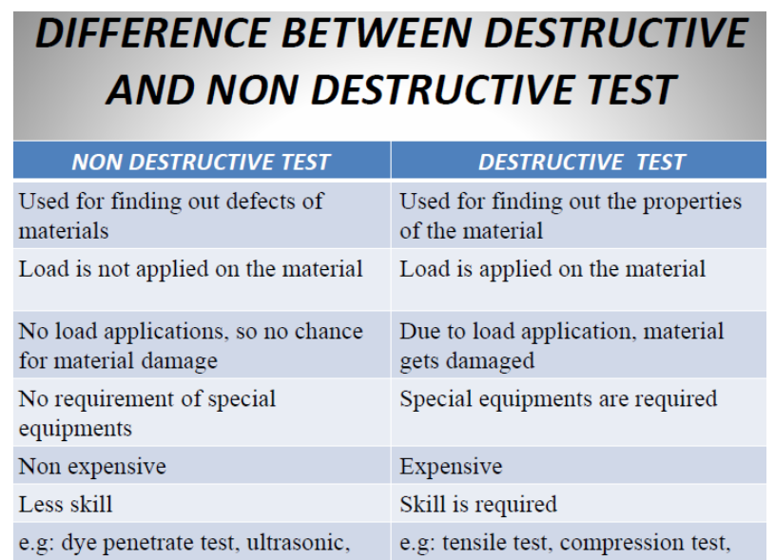

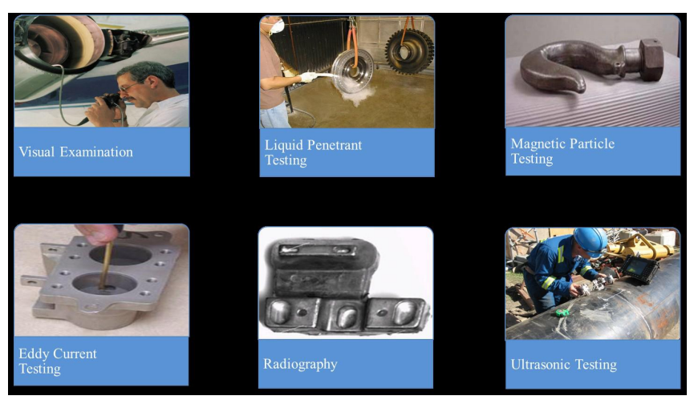

• Visual inspection is the simplest, fastest and most widely used NDT method. •

Visual inspection is commonly defined as “the examination of a material component, or product for conditions of non conformance using light and eyes, alone or in conjunction with various aids.

• Visual inspection often also involves shaking, listening, feeling, and sometimes even smelling the component being inspected.

• Visual inspection is commonly employed to support/ compliment other NDT methods.

• Digital Detector and computer technology have made it possible to automate some visual inspections. This is known as machine vision inspection.

Characteristics Detected

This visual inspection is commonly used:

1. To detect surface characteristics such as finish, Scratches, cracks or colour.
2. To check stain in transparent materials. iii. To inspect cores Principle
3. Seeing believes and the art of seeing is the visual inspection technique.
4. Visual testing requires adequate illumination of the test surface and proper eye-sight of the tester.
5. The test specimen is illuminated and the test surface is observed and examined. Whenever required, the optical aids such as mirrors, magnifying glasses, microscopes, video cameras and computer- vision system can be employed.

Advantages of VI:-

• Simple and easy to use.

• Relatively inexpensive.

• Testing speed is high.

• Testing can be performed on components which are in –service.

• Permanent record is available when latest equipment is used.

Limitation:-

• The test result depends on skill and knowledge of tester.

• Limited to detection of surface flaws.

• Eye resolution is weak.

• Eye fatigue.

Applications:-

• Checking of the surface condition of the component.

• Checking of alignment of surfaces.

• Checking of shape of the component.

• Checking for evidence of leaking.

• Checking for internal side defects.

Types of visual testing Unaided or direct visual testing, and Aided visual testing Unaided or direct visual testing

• As the name suggest, the unaided visual testing is carried out with naked eye (and without using any optical aids)

• The most important instrument is visual testing in the human eye

MAGNETIC PARTICL TESTING (MT):-

• MAGNETIC PARTICL TESTING (MT) is a non destructive testing to locate surface and sub surface discontinuities in parts made by ferromagnetic materials.

MAGNETIC LINES OF FLUX:

• It is the number of magnetic field lines passing through a surface (such as a loop of wire). The magnetic flux through a closed surface is always zero. ...

• The SI unit of magnetic flux is the Weber (Wb)

• The magnetic lines of forces existing in a magnetic field are called magnetic flux.

• The lines of flux ran through the magnets from south to north, exiting the North Pole

And re entering the South Pole

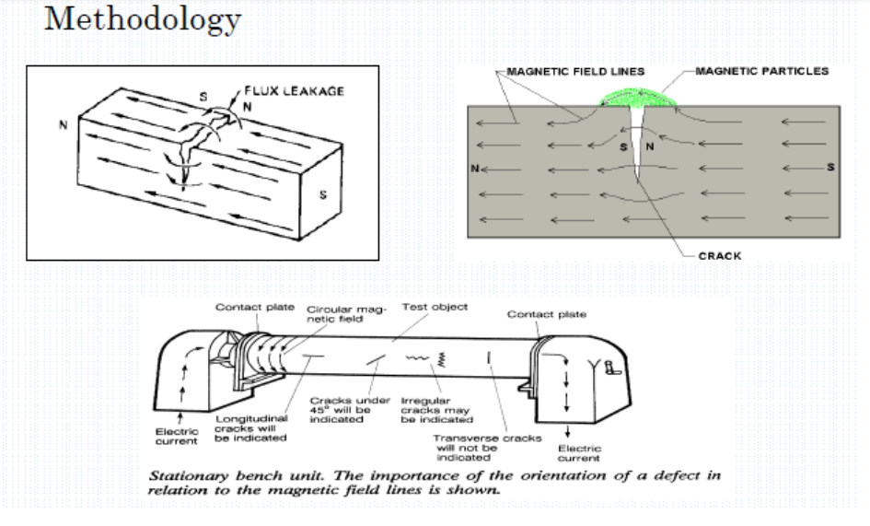.

• The lines of flux formed closed loops that never crossed.

DIRECT MAGNETIZATION:-

DIRECT MAGNETIZATION With direct magnetization, current is passed directly through¬ the component. The flow of current causes a circular magnetic field to form¬ in and around the conductor. When using the direct magnetization method, care must be¬ taken to ensure that good component (due to arcing or overheating at high resistance points).

Electrical contact is established clamping The Component between Two Electrical Contacts

• One way involves clamping the component between two electrical contacts in a special piece of equipment.

• Current is passed through the component and a circular magnetic field is established in and around the component and maintained between the test equipment and the test component to avoid damage of system.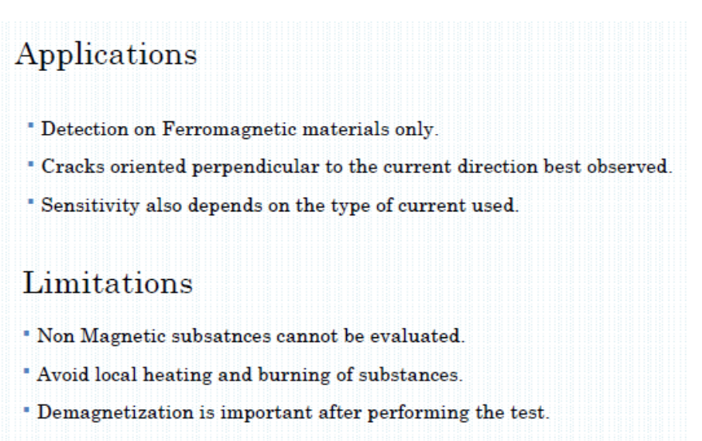

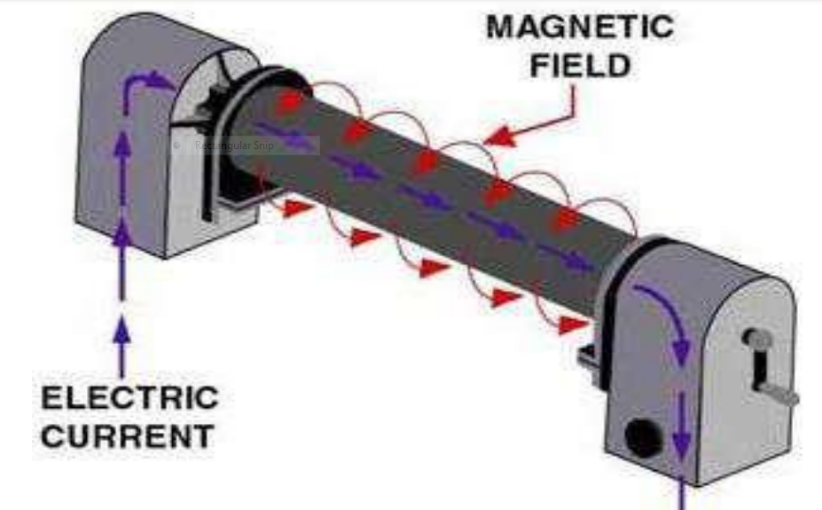

CLAMPS OR PRODS:-

A second technique involves using clamps or¬ prods, which are attached or placed in contact with the component. Electrical current flows through the¬ component from contact to contact. The current sets up a¬ c path of the current

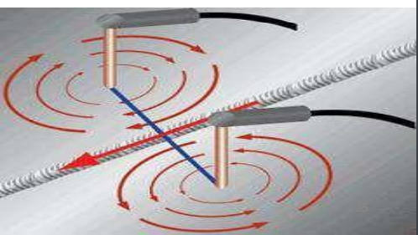

INDIRECT MAGNETIZATION:-

•Indirect magnetization is accomplished by using a strong external magnetic field to establish a magnetic field within the component. As with direct magnetization, there are several ways that indirect magnetization can be accomplished.

• PERMANENT MAGNETS:-

The use of permanent magnets is a low cost method of¬ establishing a magnetic field. However, their use is limited due to lack of control of the¬ field strength and the difficulty of placing and removing strong permanent magnets from the system.

ELECTROMAGNET:-

Electromagnets in the form of an adjustable horseshoe magnet¬ (called a yoke) eliminate the problems associated with permanent magnets and are used extensively in industry. Electromagnets only exhibit a magnetic flux when¬ electric current is flowing around the soft iron core. When the magnet is placed on the component, a magnetic¬ field is established between the north and south poles of the magnet.

